Technical Summary Document
Project/ Team Name:

Use Case:

To better understand and evaluate your Agentic AI or Multi-Agent solution, we ask you to provide a short overview and a system design process map. This will help us assess the architecture, logic, and control mechanisms behind your prototype.
Please leverage the guiding questions below to answer the main questions and include a visual representation of your system design.
The goal is to clearly explain what you built, how it works, and how you ensure it operates effectively and responsibly.
What did you build?
These are guiding questions provided as examples, feel free to answer more broadly or ignore them if you prefer.
- What is the goal of your solution? (Briefly describe how this is tackling the use case selected)
- What are the key components of your system? (List agents, tools, APIs, or modules involved)

How did you build it?
These are guiding questions provided as examples, feel free to answer more broadly or ignore them if you prefer.
- How do agent(s) interact within the system? Is there an orchestrator? Do agents act independently, in sequence, or collaborate?
- What kind of data or knowledge base powers your system? Public datasets, proprietary data, synthetic inputs, etc.
- Which technologies or frameworks are used? (e.g. LLMs, LangChain, AutoGen, ReAct, custom agents, etc.)

How do you control and evaluate it?
These are guiding questions provided as examples, feel free to answer more broadly or ignore them if you prefer.
- How do you ensure the agents behave as expected? Are there rules, evaluation layers, fallback mechanisms, or supervision?
- How do you monitor system performance and outputs? Any metrics, checkpoints, logging, or manual review steps?
- What are the limitations and known risks? Autonomy issues, hallucinations, scalability, etc.

Process Design Map
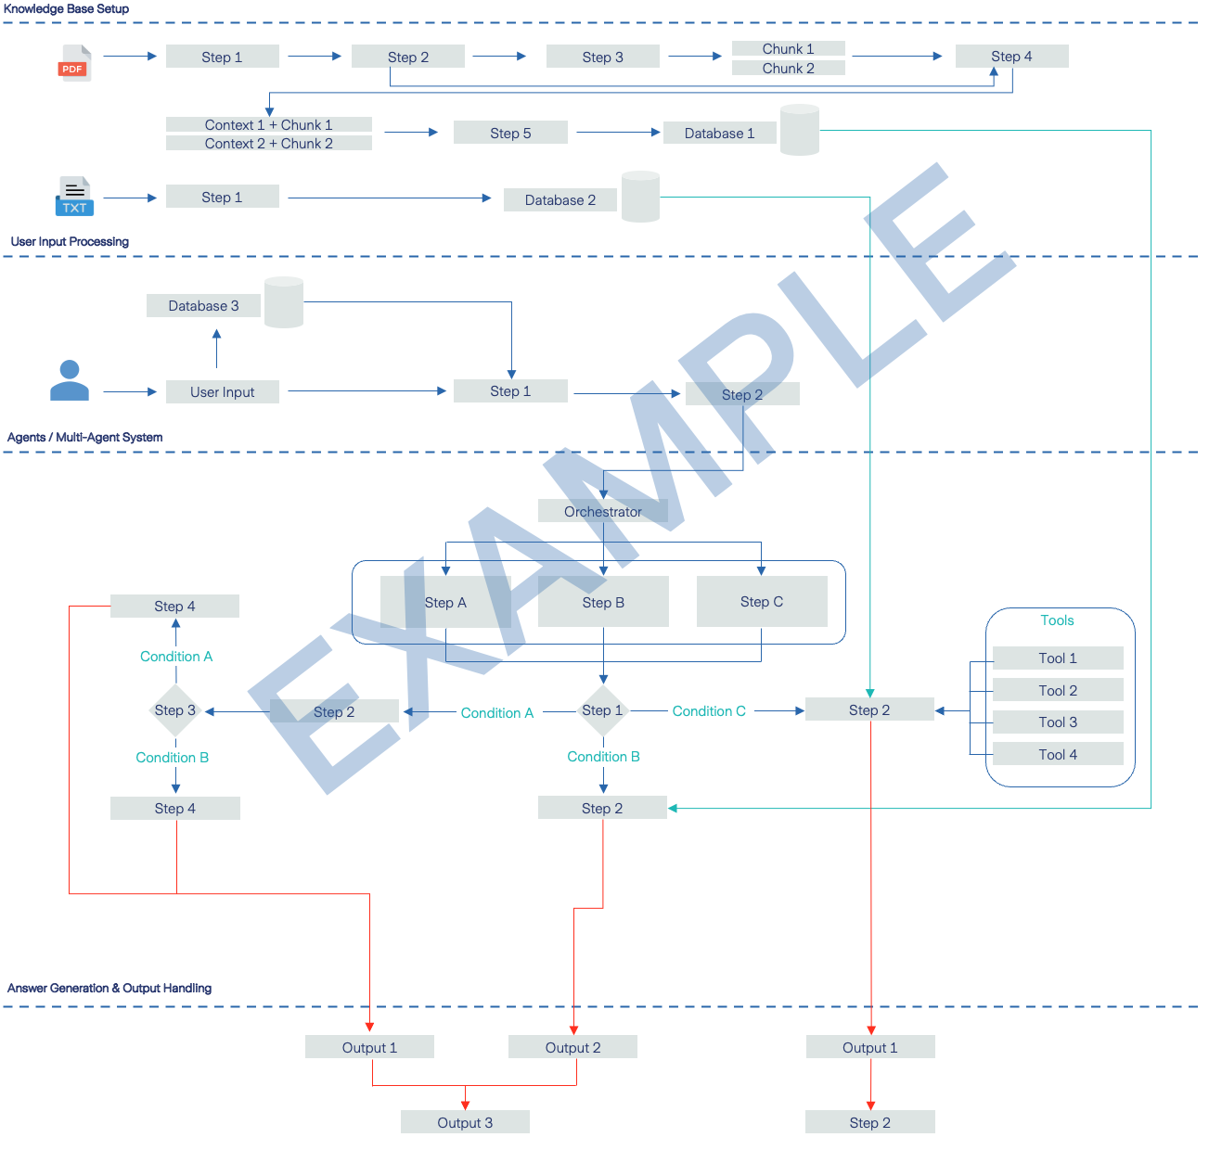
Provide a Design Process Map that clearly illustrates the end-to-end architecture of your Agentic or Multi-Agent AI solution. This should be a high-level yet structured visual or descriptive overview of how your system operates,from input to output, highlighting the interaction between components at each step. For every stage of the design, please specify which Large Language Models (LLMs) and orchestration tools or techniques were used.
[Please insert below the images, feel free to add pages to have enough space – otherwise you can upload it as a separate document in the dedicated submission folder]

